3.1 Graph Linear Equations in Two Variables
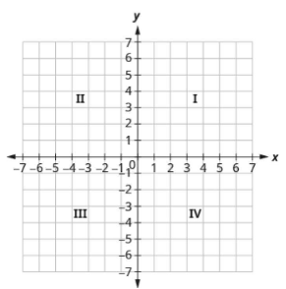
An ordered pair (x, y) gives the coordinates in a rectangular coordinate syste.

The first number always represents the
____-coordinate and describes the
horizontal position of the point

The second number always represents the
____-coordinate and describes the vertical position of the point

The point (0, 0) is called the ____________

There are 4 quadrants, each describe the sign of the two coordinates

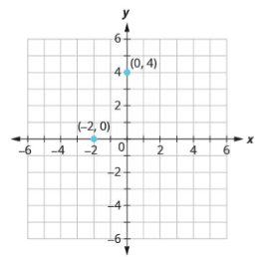
(0, 4) and (-2, 0) are shown.
Plot (-5, 4) and (3, )

Linear equations in two variables may be in the form Ax + By = C.

This form is called _____________

A solution is an ordered pair that makes an equation into a true statement.

Graph: by plotting points

Graph: y = 3

Graph: x = 2

The x-intercept of a line is the point (___, 0) where the line crosses the x-axis
The y-intercept of a line is the point (0, ___) where the line crosses the y-axis

Find the x- and y-intercepts of 2x + y = 8

Graph 4x - 3y = 12 using the intercepts.
Afterward, find a third solution and verify that it lies on the line

Section 3.2 - Slope of a Line
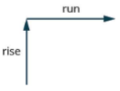
The slope of a line is

Find the slope of the line that contains (0, 5) and (3, 3)

Find the slope of the line that contains (-3, 4) and (2, -1)

What is the slope of a vertical line?

Graph the line passing through the point (1, -1) whose slope is

Graph the line passing through the point (2, -2) whose slope is

Graph the line passing through the point (-2, 3) whose slope is

Graph the line with a slope of that has a y-intercept of 3

Slope-Intercept Form: y = mx + b
m - slope
b - y-intercept, specifically the point (0, b)

Identify the slope and y-intercept of

Identify the slope and y-intercept of

Graph y = -x + 4 using its slope and y-intercept

Section 3.3 - Find the equation of a line
Find the equation of the line with a slope of -9 and a y-intercept (0, -4)

Find the equation of the line that contains (3, -2) and (0, -3)

If you have a slope and a generic point (not the y-intercept), you can use the point-slope form or
y = mx + b
Plug in your point and the slope, and solve the formula to find b.

Find the equation of the line that has a slope of that contains the point (6, -4), in slope-intercept form.

Find the equation of the line that has a slope of that contains the point (10, -5), in slope-intercept form.

Find the equation of the line that has a slope of that contains the point (4, -7), in slope-intercept form.
Find the equation of the line that contains the points (-3, -1) and (2, -2)

Find the equation of the line that contains the points (5, 1), and (5, -4)

Find the equation of the line that contains the points (2, 3) and (-4, 6)

Find the equation of the line that contains the points (-4, 4) and (-1, 4)
Find the equation of the line that is parallel to y = 2x - 3 but passes through (-2, 1)

Find the equation of the line that is perpendicular to y = 2x - 3, but passes through (-2, 1)

Find the equation of the line that is perpendicular to y = 3x + 1 that contains (4, 2)

Find the equation of the line that is parallel to that contains (6, 4)
Find the equation of the line that is perpendicular to x = 4 that contains the point (4, -5)

Find the equation of the line that is parallel to the line x = 4 that contains the point (2, -1)
Section 3.5 - Relations and Functions
Consider a teacher's class roster that contains students names and their ID#
(Student name, Student ID #)

This roster is a rule that relates the two sets of data (names and IDs) called a relation.

A relation is a set of ordered pairs (x, y). All the x-values in the ordered pairs together make up the domain, while all the y-values in the ordered pairs together make up the range.

Consider the relation
{(1, 1), (2, 4), (3, 9), (4, 16), (5, 25)}
Find the domain of the relation

Find the range of the relation

A mapping is a graphical way to represent a relation
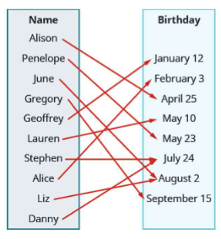

What is the domain of this mapping?

What is the range of this mapping?

To graph a relation, we plot all the ordered pairs as points
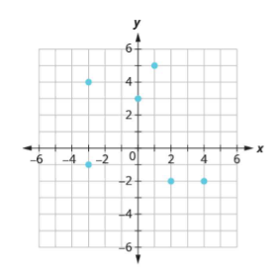

What is the domain of this relation?

What is the range of this relation?

A special type of relation, called a function, is used extensively in mathematics. A function is a relation that assigns each element in the domain to exactly one element in the range.
Consider the names->birthday example

Is it possible for there to be multiple arrows from Allison?

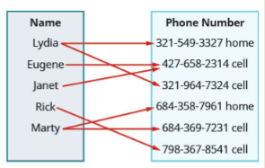
Determine if the given set of ordered pairs represents a function
{ (-3, 27), (-2, 8), (-1, 1), (0, 0), (1, 1), (2, 8), (3, 27) }

{ (9, -3), (4, -2), (1, -1), (0, 0), (1, 1) }

{ (1, 2), (1, 5), (2, 3), (3, 6) }

Determine whether each equation is a function

2x + y = 7

y = x² + 1

x + y² = 3
Find the value of a function, function notation

For the function y = f(x)

f is the name of the function
x is the domain value (think of this as an input)
f(x) is the range value, which we also call y here (this of this as the output)

'f of x'

x is the independent variable
y is the dependent variable, since its value depends on x

Suppose f(x) = 4x - 5, find f(2)

For the function f(x) = 2x² + 3x - 1, evaluate the following

a) f(3)

b) f(-2)

c) f(a)

For the function g(x) = 3x - 5, evaluate the following

a) g(h²)

b) g(x + 2)

c) g(x) + g(2)
Section 3.6 - Graphs of Functions
Decide whether each graph is the graph of a function
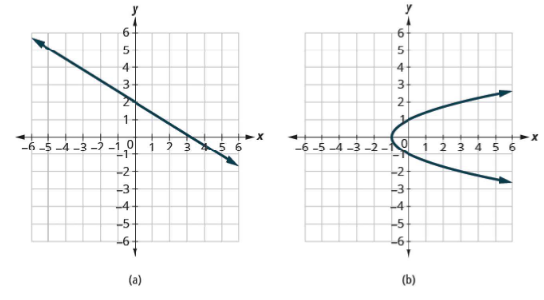

The vertical line test says if any vertical line intersects a graph in more than one point, it does not represent a function

Which of the following are functions? Give their domains and ranges
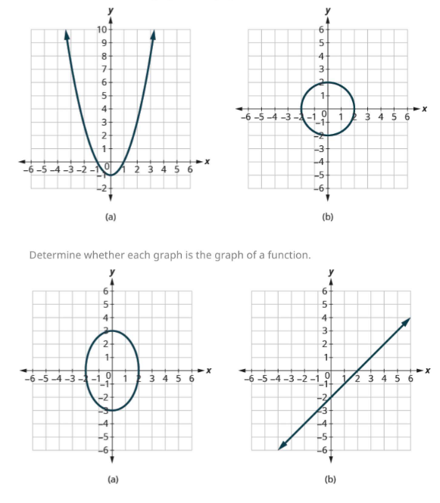
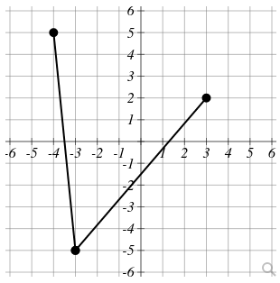
Give the domain and range

Is this a function?

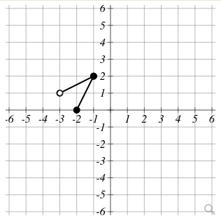

Give the domain and range

Is this a function?

Graph f(x) = | 5x - 1 |

What is its domain and range?
Identifying graphs
